**Arabian Dream**

**Trading**

**&**

**Contracting Company**

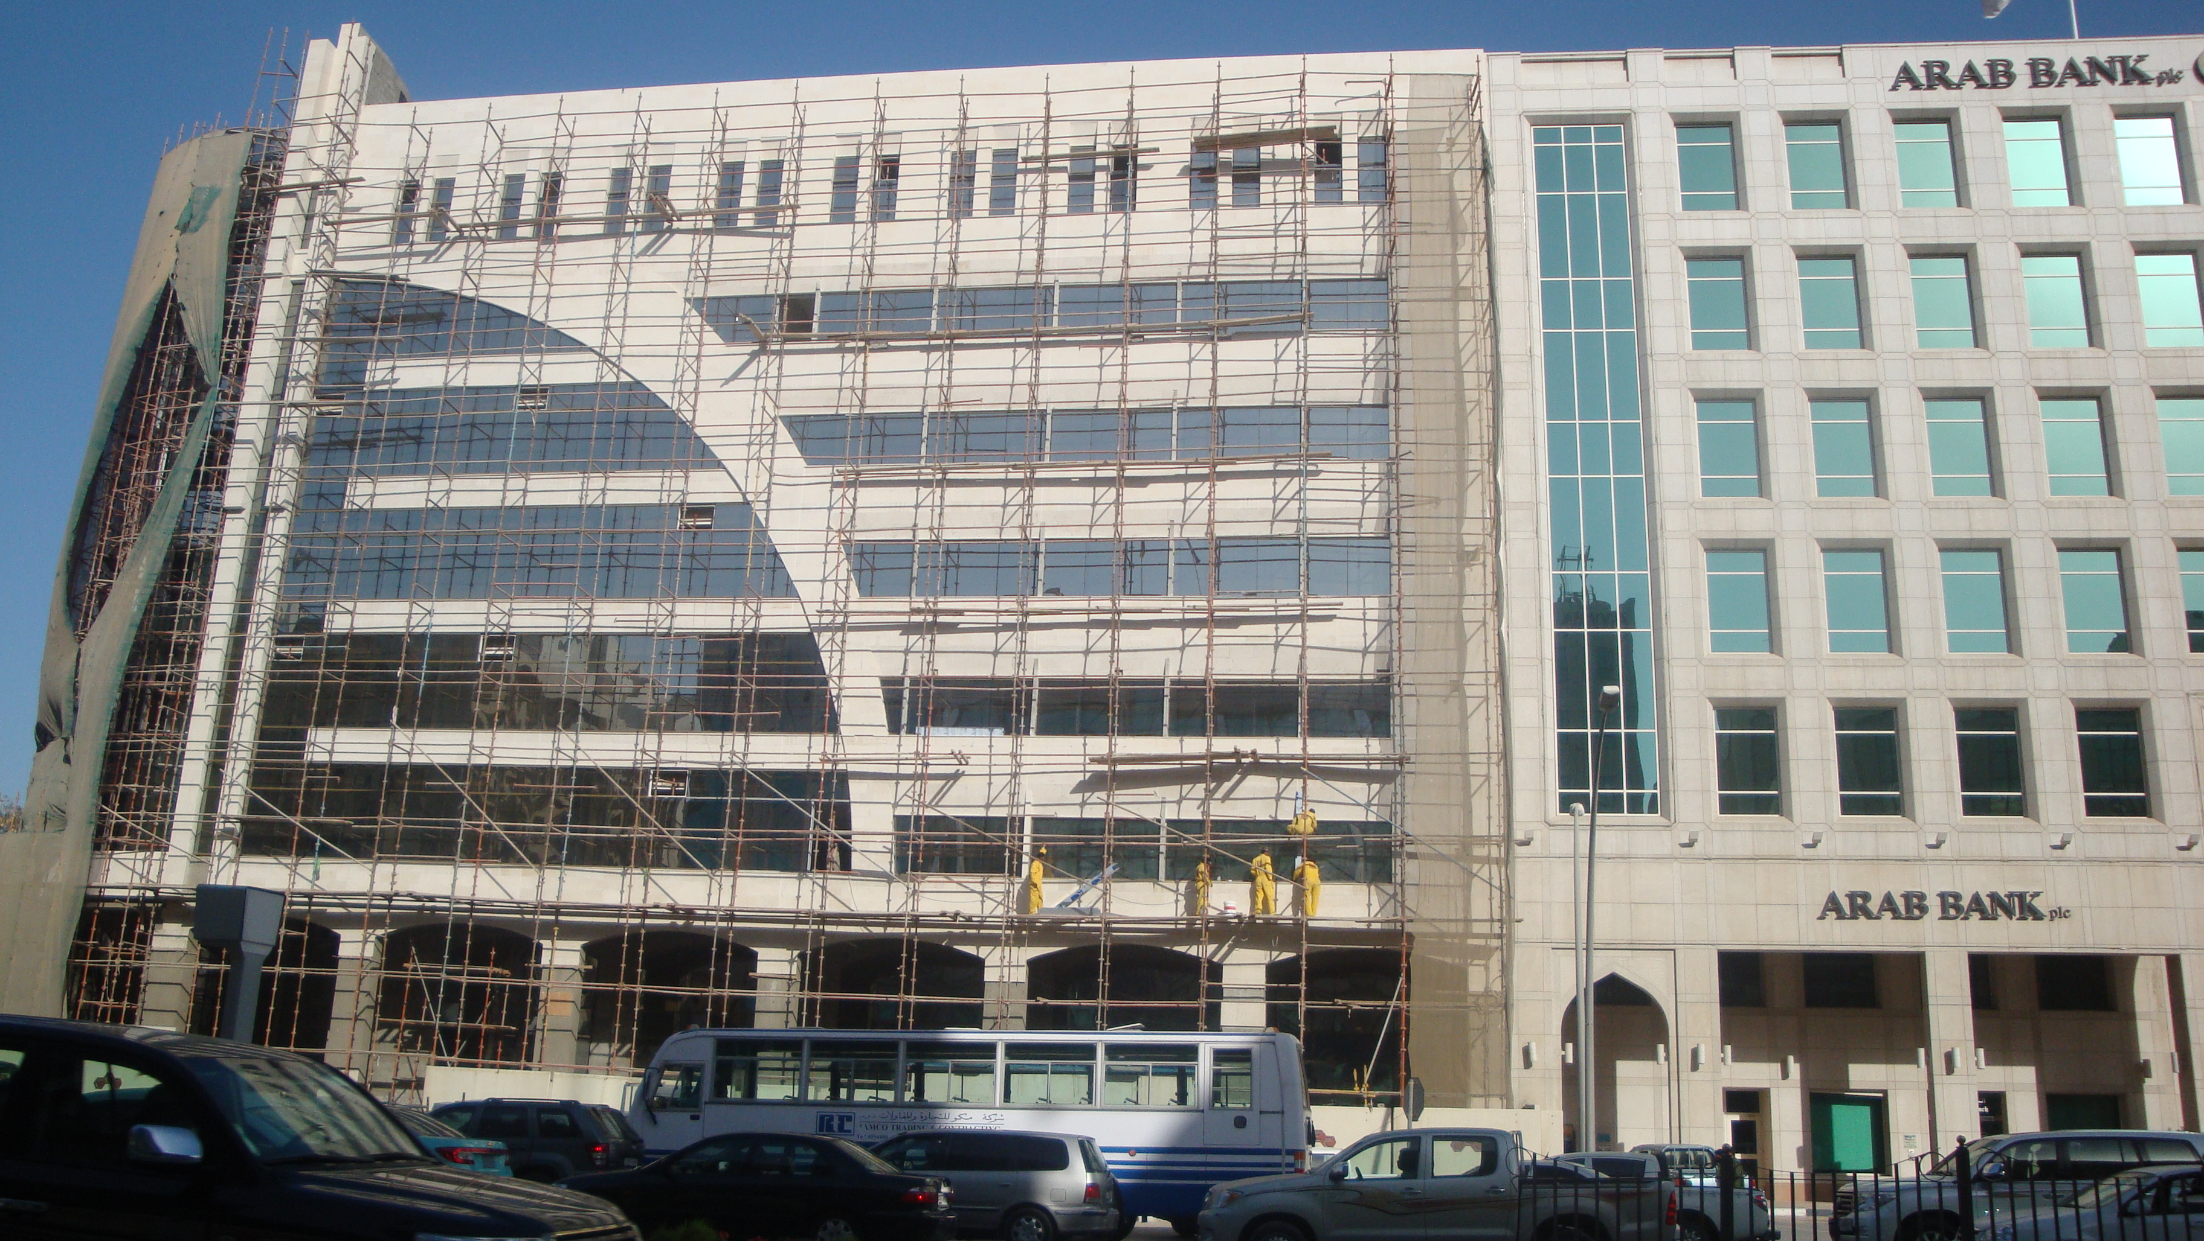

**Overview**

Arabian Dream Trading & Contracting made a giant leap forward in the construction industry under the leadership and guidance by its board of directors Mr. Sultan Jasim Al Jasim, and Mr. Feras Mohammadieh.

Here at Arab Dream we understand the exact needs of our customers and ensured the best quality of materials and workmanship, enjoyed an excellent relationship with our clientele, sub-contractors, consultants and our suppliers. Arab Dream is ready to compete and become one of the fastest growing contracting companies in Qatar.

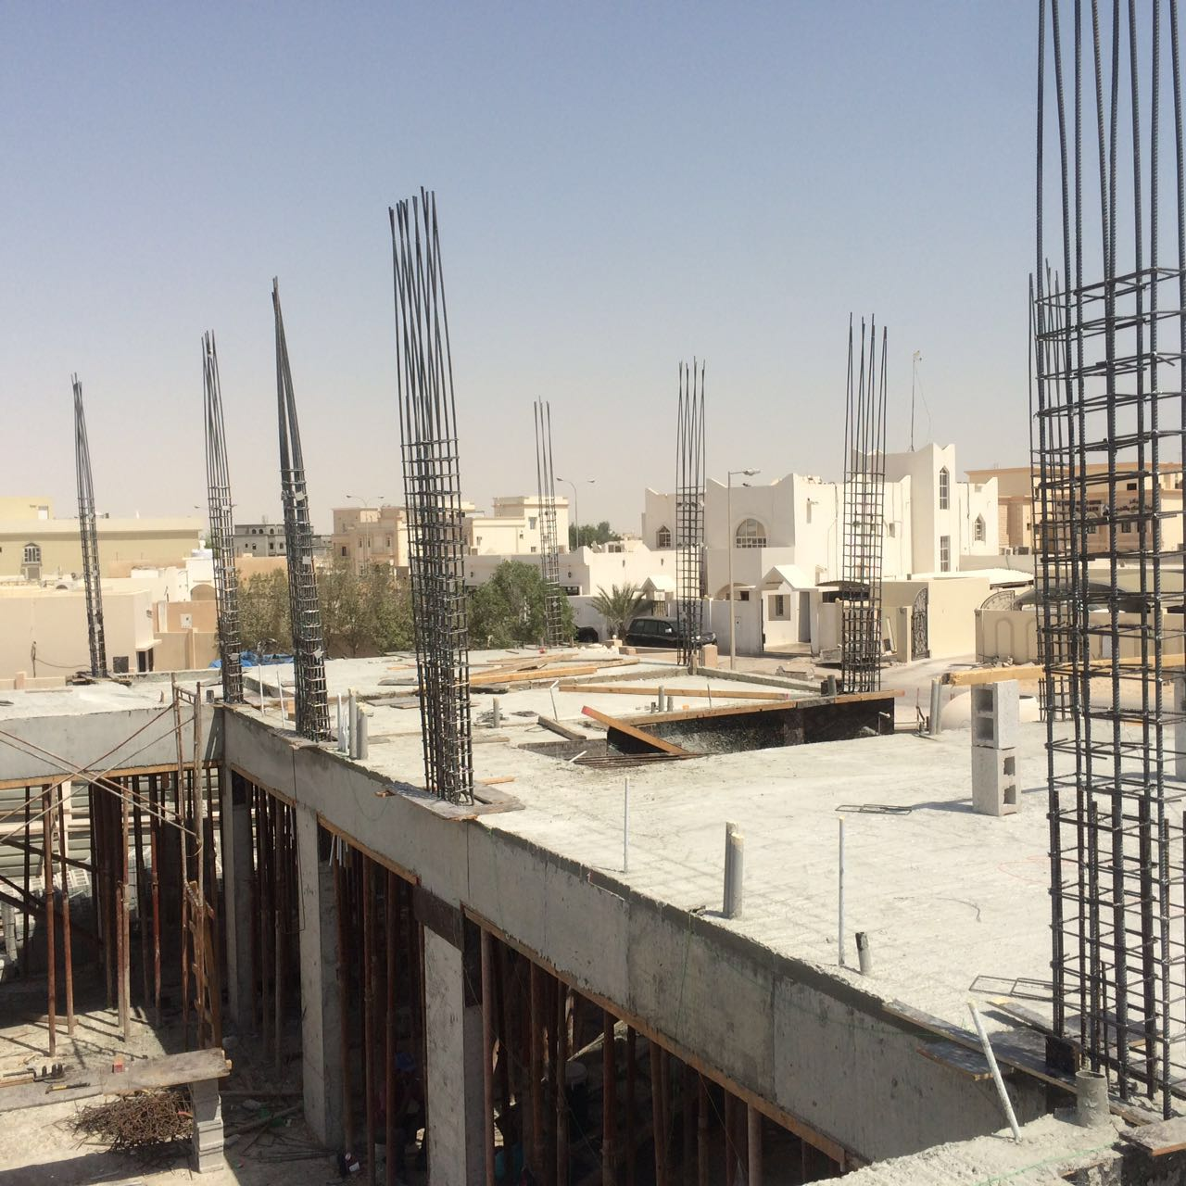

Arab Dream takes pride in keeping an impressive record of successful projects that have been completed in record timing and have also been very economically beneficial for both parties, not only satisfying our clients, but also ensuring quality and excellence throughout all of our projects. All of which is done through well assembled and highly qualified management.



**Introduction**

Arab Dream was originally established in 2004, where it was a limited liability company which specialized in general contracting and maintenance work.

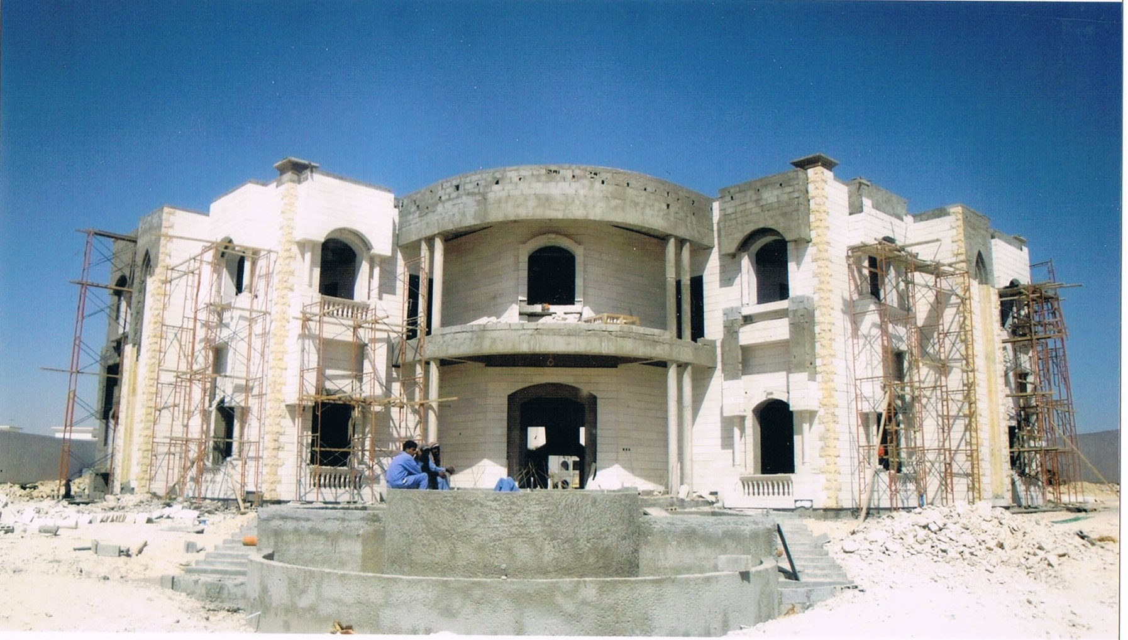We started on a very small scale and with limited labors. After two years of hard work and faithfulness to the company we began to grow, increasing our number of labors, company vehicles, equipment, and tools meaning that we were now able to become involved with much bigger contracts, and continue to grow as a contracting company.

We have established a material branch to provide our mother company, Arabian Dream with materials from different factories across parts of Asia, Europe, and the Gulf. Such materials include Ceramics, natural stone, industrial stone, marble granite interlock, cement tiles, and much more. We are also proud to say that we have become the official agents to these factories as wellWe are now a competitive company that is ready to complete projects in both the privet sector as well as the government sector Our offices are located at Um Ghueilina and our stores are located at Al Wakra. We have over 150 labors working for our projects in addition to 20 administrative employees distributed to the management, accounting, and marketing divisions.

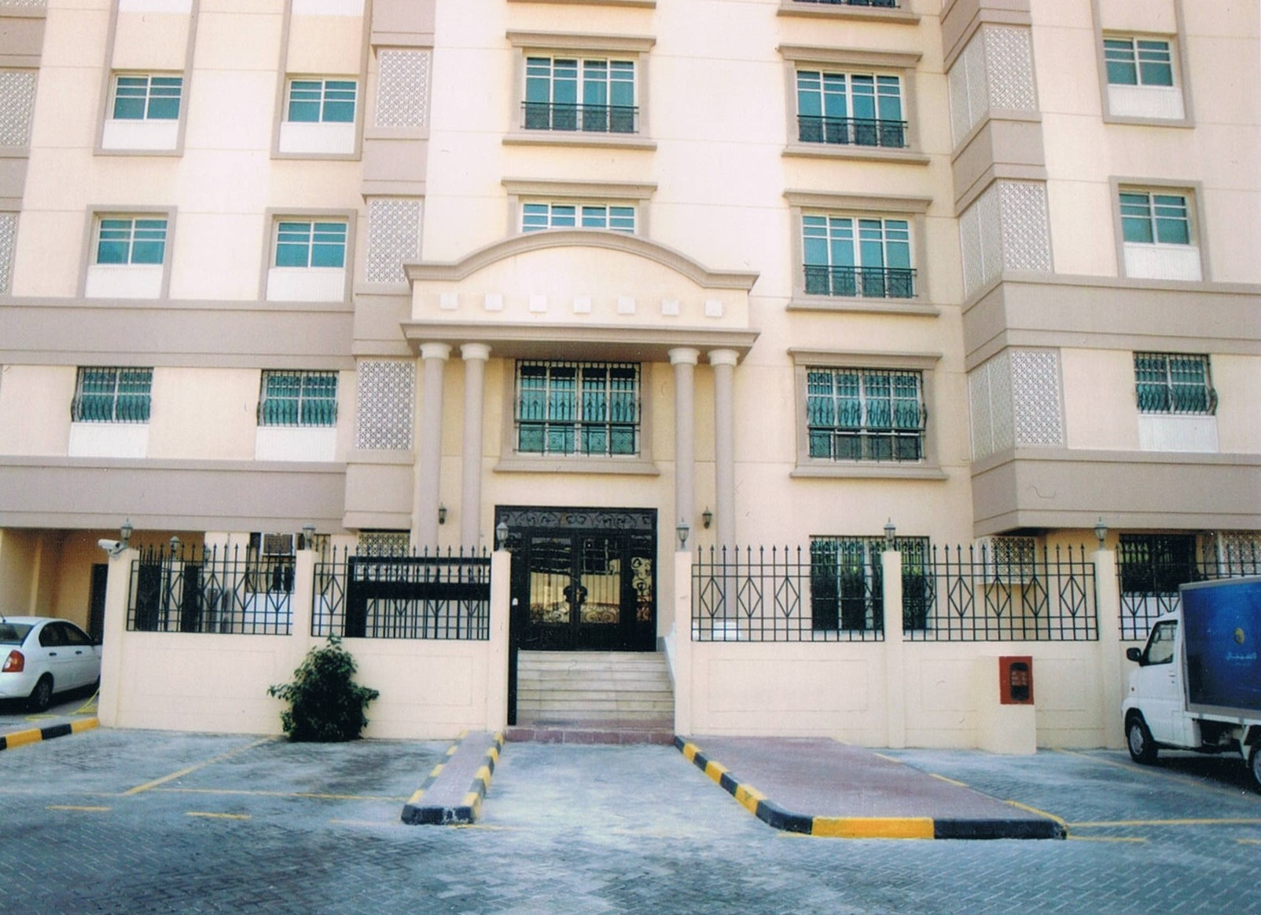





**Our Vision & Mission**

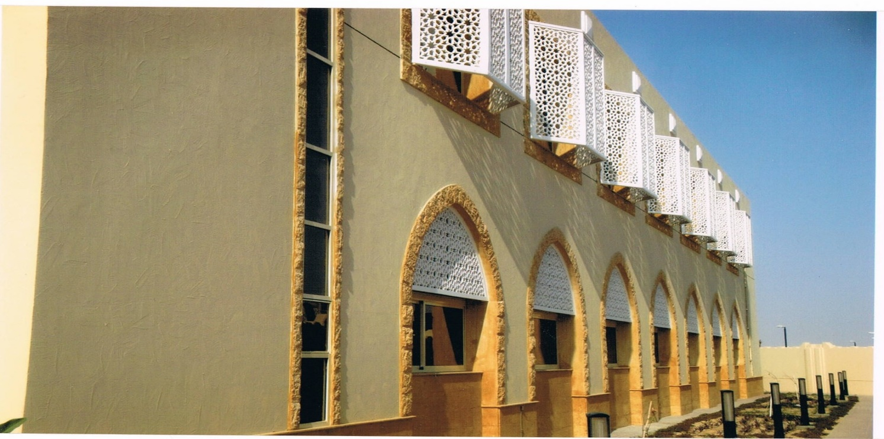The vision here at Arabian Dream is to maintain our status as one of the leading contracting companies in Qatar while continuing to contribute to the development of our society and to the environment.

The mission of Arabian Dream is to grow into a leading contracting company in Qatar. Ultimately to become the first option without any compromise to deliver the best quality construction in Qatar with total commitment to excellence and devotion to our customers.

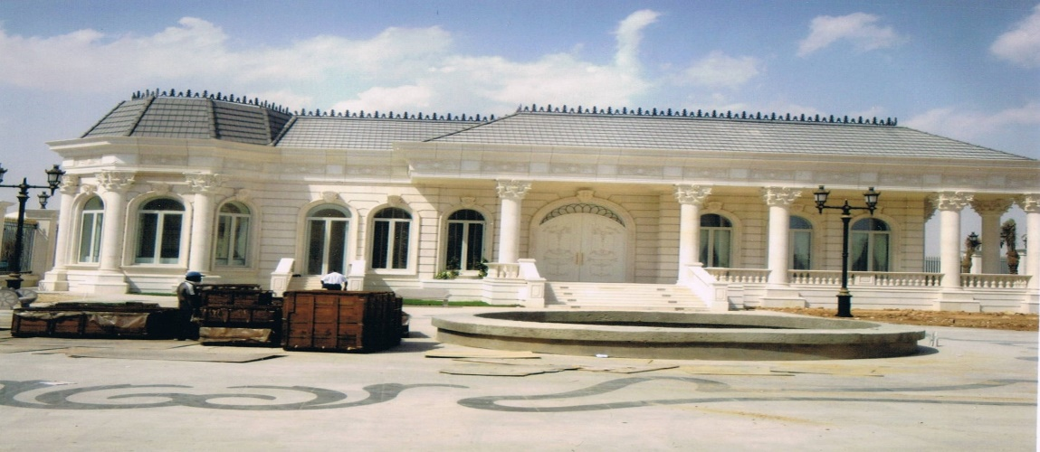

Organizational Chart

Below is a chart that describes the organization of Arab Dreams.

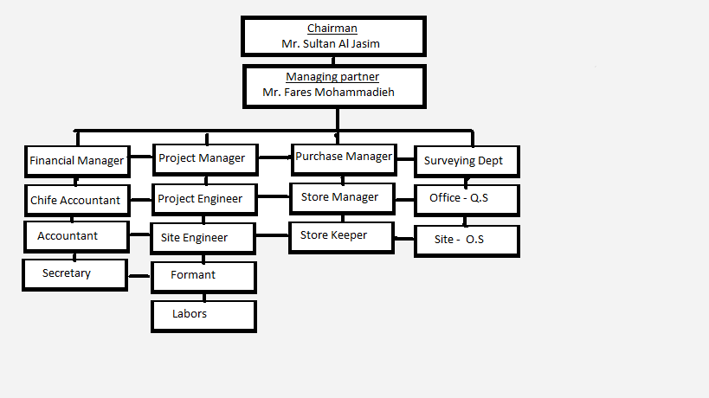

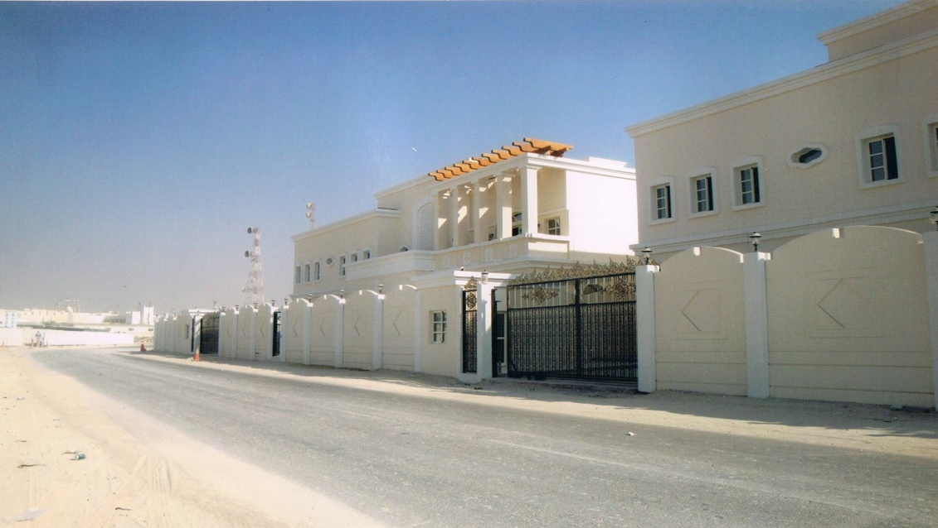



Present & Previous Projects:

Materials Supply

1. **Ministry of Interior**

* Main buildings of interior - Bin Imran
* 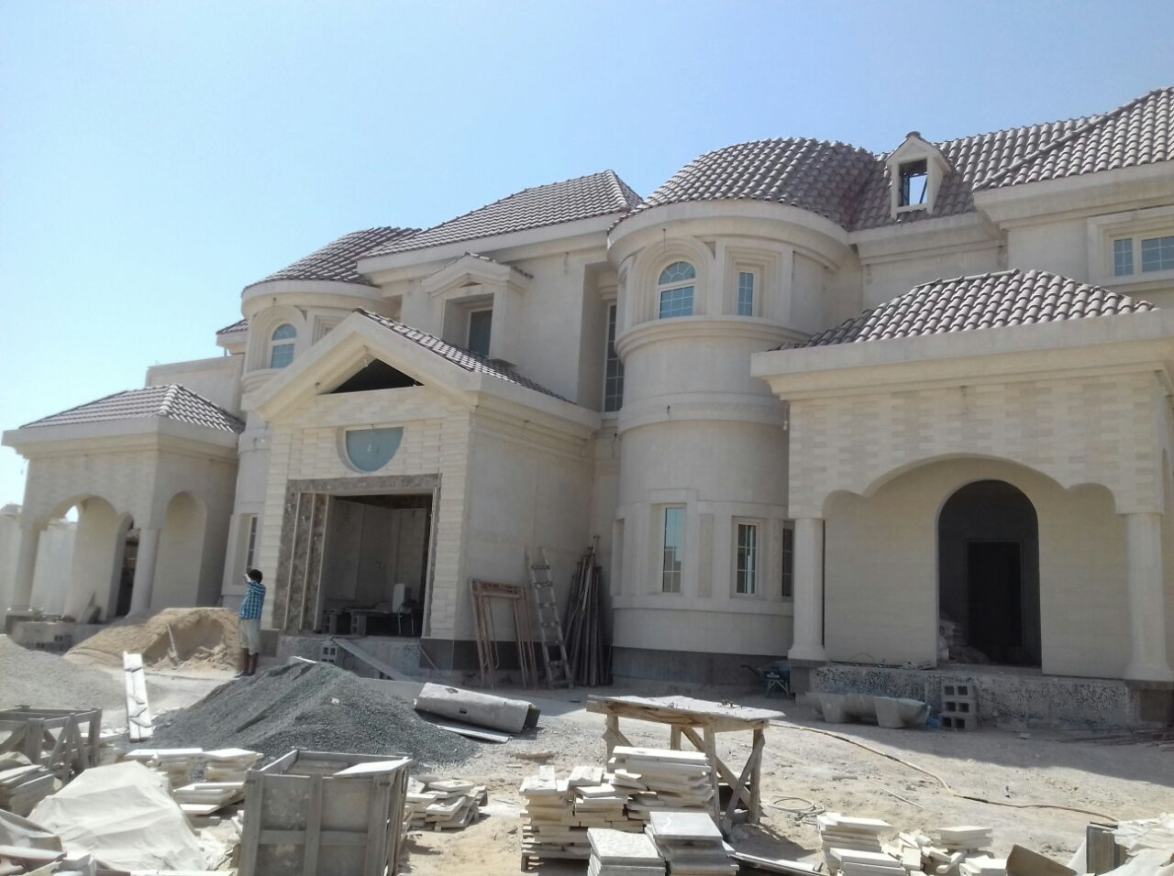Police Station – Shahaniah
* Civil Defiance – Shahaniah
* Traffic Station – Al Mamoura

1. **Ministry of Foreign Affairs**

* Women Quran Center – Al Wa’ab
* Women Quran Center – Meazer

1. **Hotels**

* La – Sigal Hotel - Al Sa’ad
* Sheraton Hotel – Al Dafnah
* Regis Hotel – Al Beda’a
* Al Sharq Hotel - Raas Abu Abud

1. **Sports Clubs**

* Al Arabia Sports Club
* Al Khor Sports Club
* Al Wakra Sports Club
* Al Gharafa Sports Club
* Qatar Sports Club



1. **Car Show Rooms**

* BMW Show Room – Al Sa’ad
* Toyota Show Room – Old Airport
* Nissan Show Room – Ramada Signal
* Audi Show Room – Ramada Signal
* Mazda Show Room – AL Andalus Signal

1. **Electronic Show Rooms**

* Panasonic Show Rooms
* Qtel Show Rooms
* Nokia Showrooms

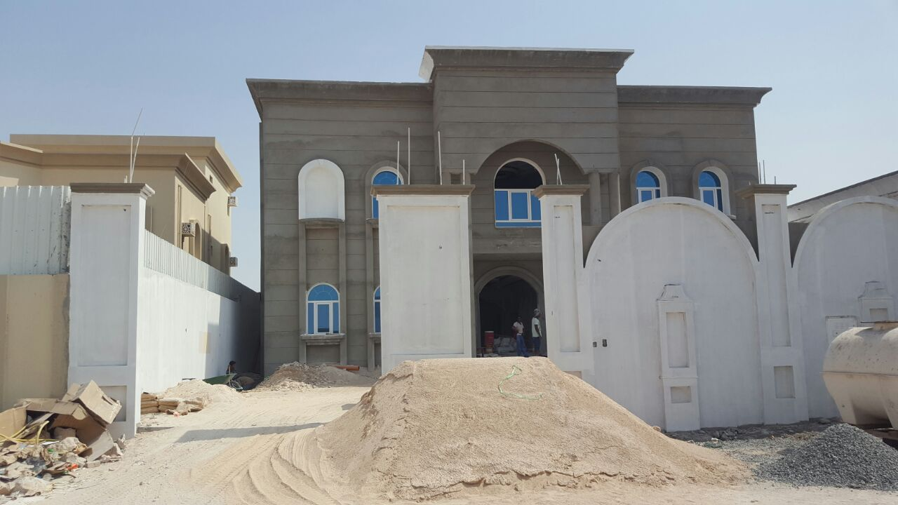

1. **Villa Compounds**

* West Bay Compounds – Al Diasel
* Raas Abu Abud Compounds – Genco
* Al Garafa Compounds – Al aali
* Hamad Al Attya – Derwind

1. **Residential & Commercial Buildings**

* Al Majida Building
* HK. Abdul Aziz Al Thani Buildings
* HK. Saud Bin Fahad Buildings
* Al Gida Buildings
* Al Jasim Group Buildings

**Executive Summary**

Arabian Dream is a civil contracting company, Arabian Dream has successfully operated in Qatar since 2004 working in both large scale and miniature scale contracting, repair, and modification projects. With the boom of business that is occurring in our local area the desire to perfect our company is stronger than ever, we are now planning to expand Arabian Dream to large commercial customers, this business plan has laid out our goals to make this transition successful and create enough market shares to succeed in this highly competitive market.

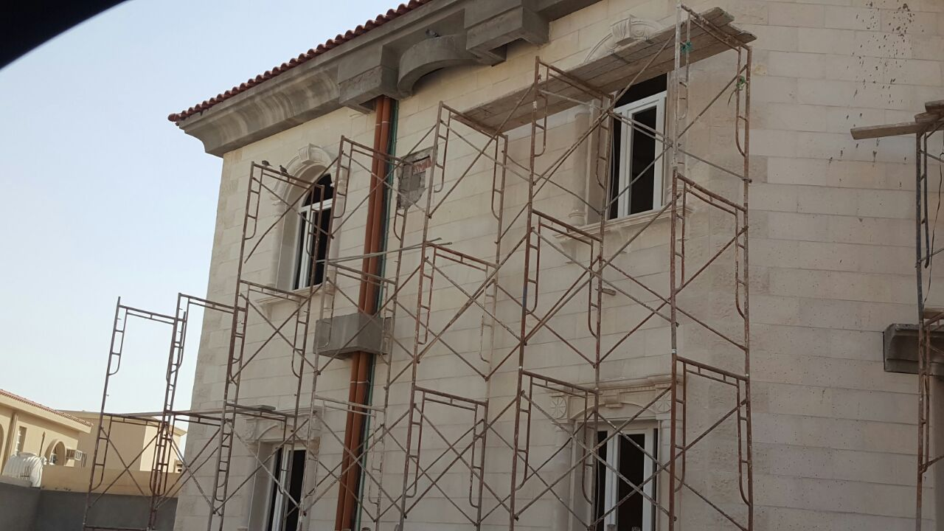

Qatar is booming at this moment and overall business growth these past few years has allowed us to expand to this point and we expect to do so even more in the following years as we reach our peak.

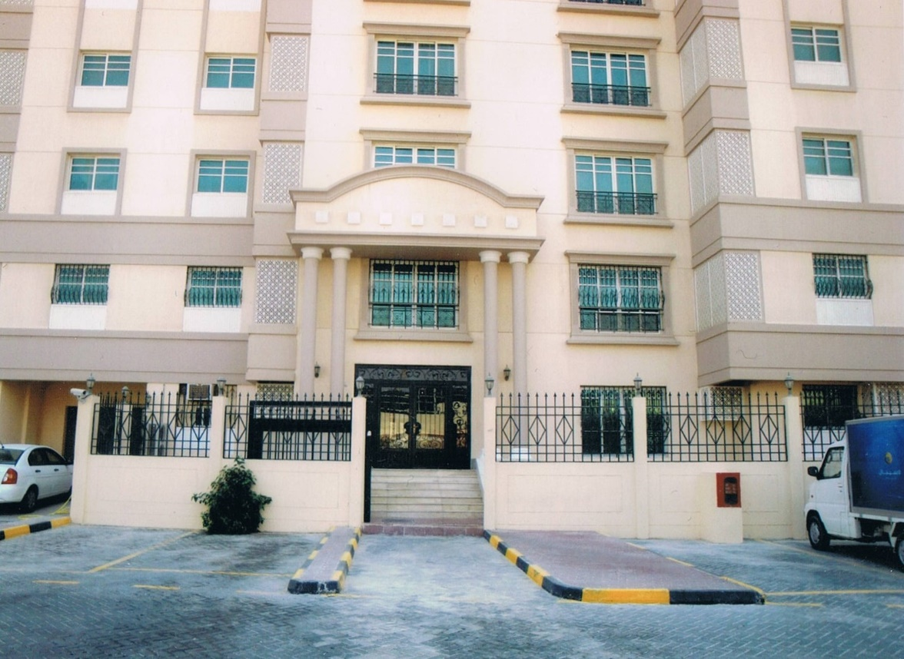

**Residential buildings**

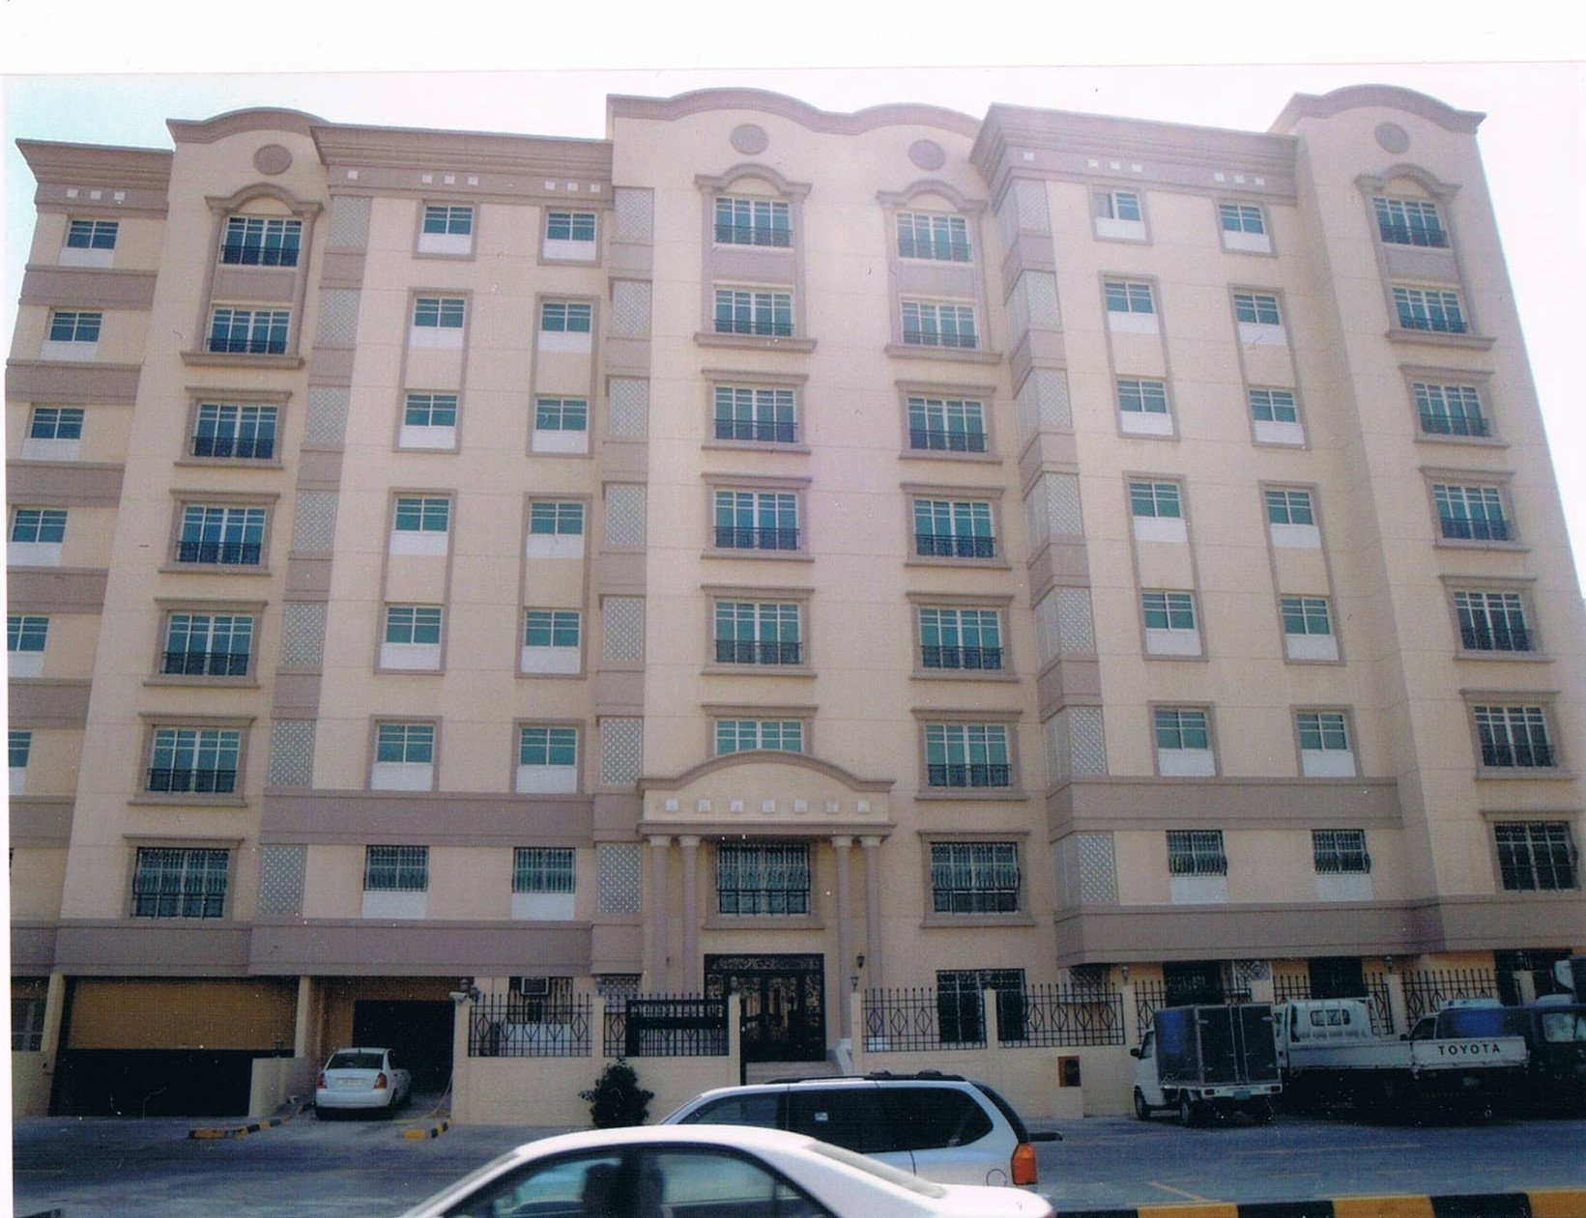



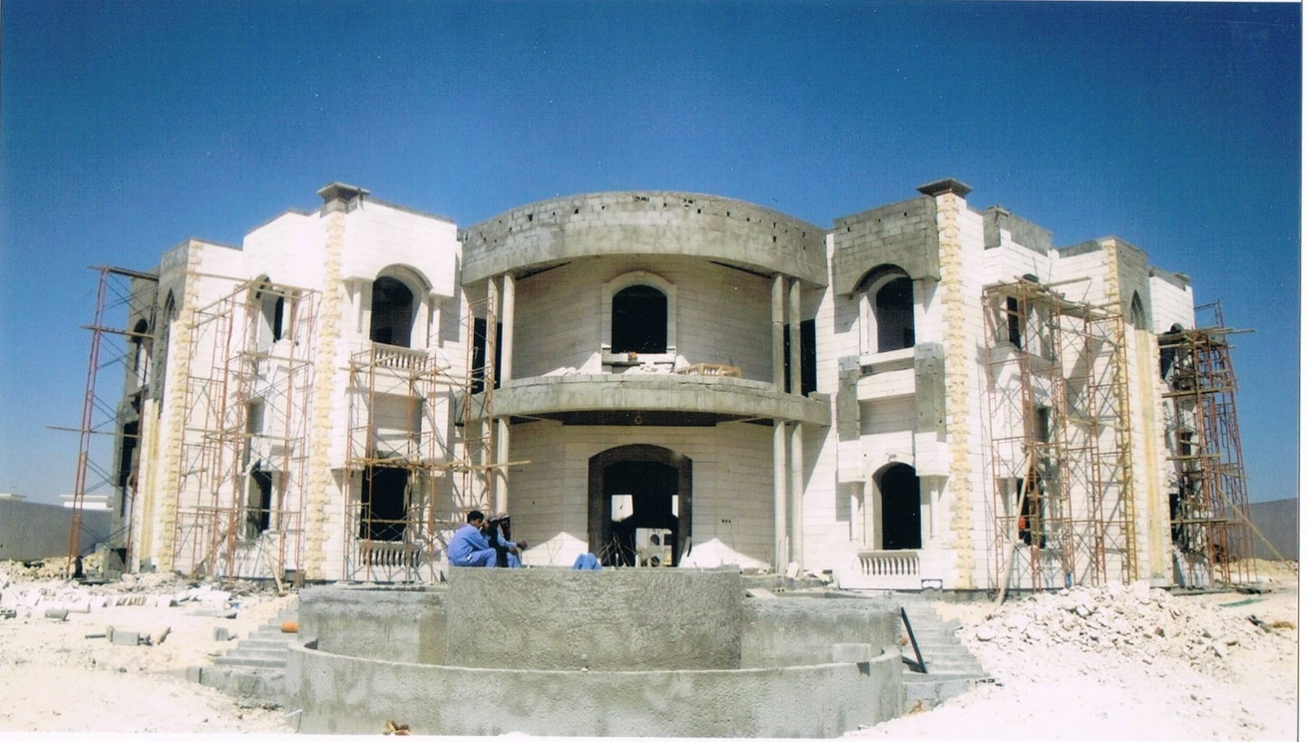

**Private Villas**

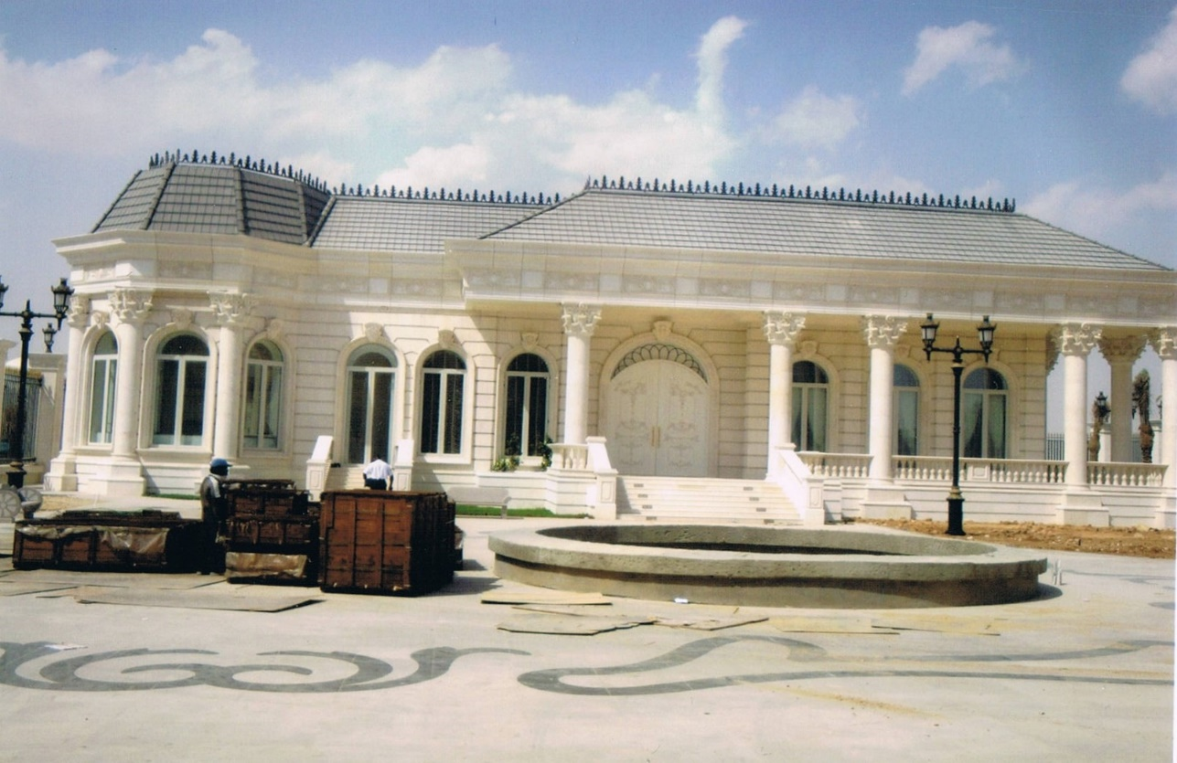



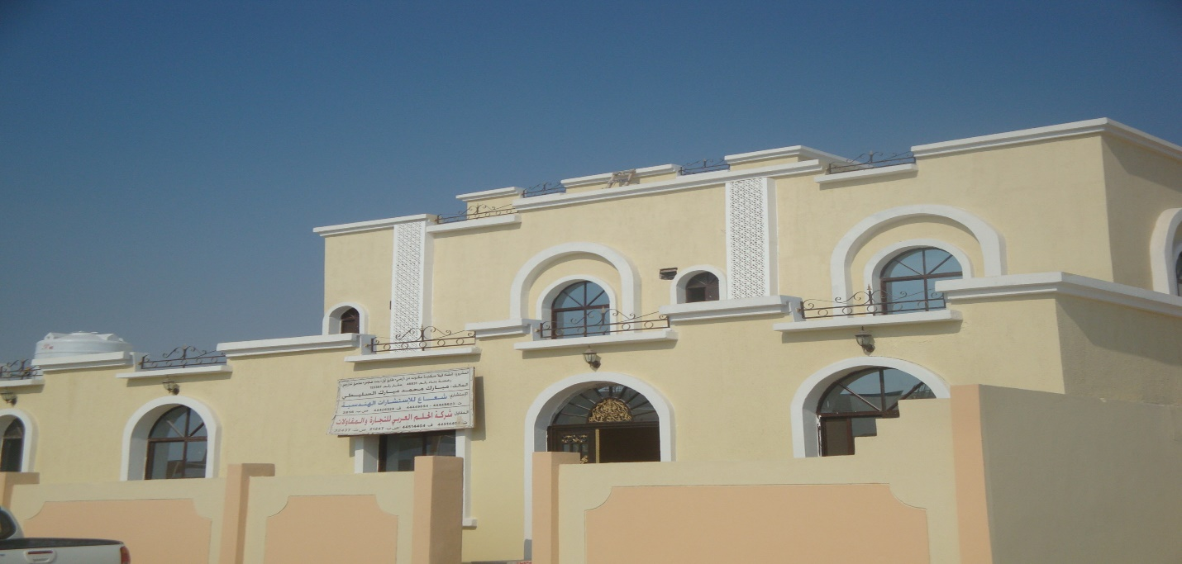

**Private Villas**

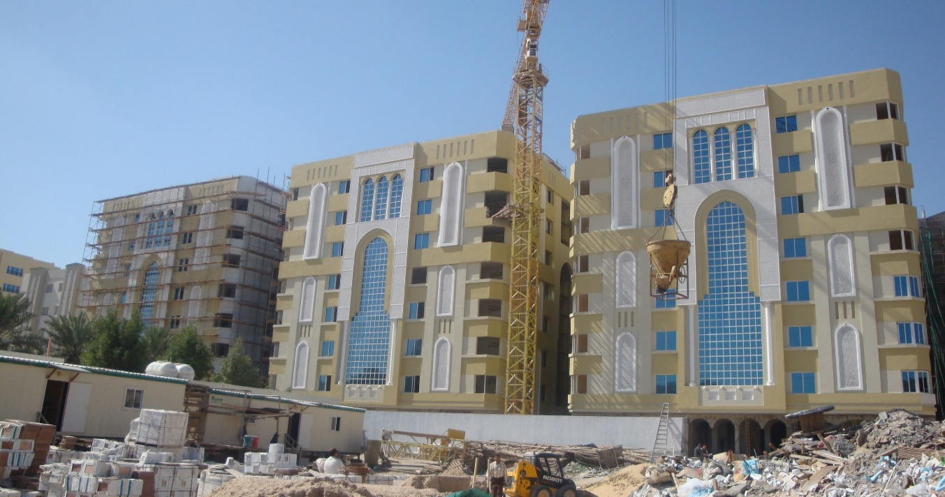

**Commercial Buildings**







